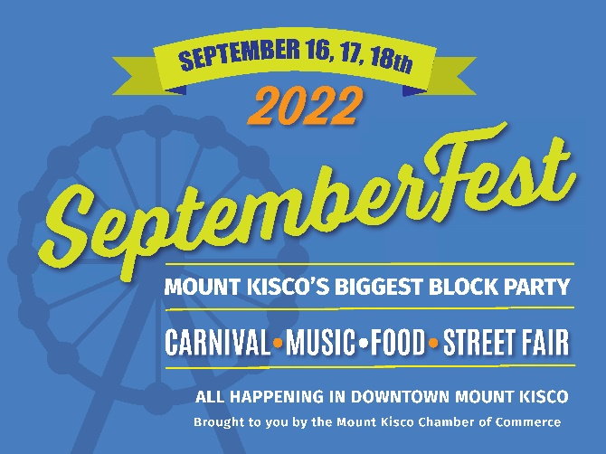
SeptemberFest...It’s Big…It’s Bold…
You need to be in it!

VENDORS WANTED FOR FESTIVAL STREET FAIR

Sponsorships Available

Showcase your business/org, products, services, pop-up shop or on-line business at Mt Kisco’s Largest Event!
STREET FAIR DATES & TIMES: SAT., SEPT. 17 (11AM – 6PM)
SUN., SEPT. 18 (12PM-4PM)

Please indicate option:
Mt Kisco Chamber Member: So. Moger Ave Sidewalk Table Space w/ one display table |  | - $150
Non-Member: So. Moger Ave Sidewalk Table Space w/ one display table |  | - $295
Non-Member- Not-for-Profit Org: So. Moger Ave Sidewalk Table Space w/ one display table |  | - $195
Additional Sidewalk Space: w/additional display table |  | - $100
Pop-up Cabana Tent Area (limited # of spaces available and placed in designated pop-up tent location only - Includes 2 display tables. Must bring own 10x10 pop-up tent) |  | - $350
Fest Jumbo Display –For vehicle, sporting equipment or large product – (only 2 spots available) |  | - $750
*Special Sponsorship Opportunities Available : Act fast - Limited Number – see list or call Chamber Office directly 914-666-7525 |  | $__________

- Participation Fees include Vendor Space for both (2) days of SeptemberFest 2022 (see fee schedule above).
- All reservation requests are pending approval by the Mount Kisco Chamber of Commerce.
- Specific vendor space location assignments/placements are at the sole discretion of the MKCC event managers.
- Designated Pop-Up Cabana Tent Area is located aside the festival food & entertainment area.
- Absolutely no pop-up tents are allowed on the So. Moger Ave sidewalk. Electricity is NOT available.
- No food & beverage sales are permitted by Vendors.
- Recommend bringing a portable chair & small shade umbrella (ex: portable 3.4x3.5 umbrellas w clamp).
- This is a rain or shine event. NO REFUNDS.
- Certificate of Insurance or Waiver is required upon approval and must be submitted prior to event.

Business /Company/Organization Name ________________________________________________________

Contact Person ____________________________________Phone__________________________________

Email ___________________________________________________________________________________

Mailing Address____________________________________________________________________________

Type of Product, Goods or Services____________________________________________________________

Apply on online www.mtkiscochamber.com or complete this application and return with payment to:
Mount Kisco Chamber of Commerce / 3 North Moger Avenue / Mount Kisco, NY 10549
Phone: (914) 666-7525 / Email: mkccseptemberfest@gmail.com

Credit Card: Visa Master Card American Express Total $ ________________

Card # ________________________________________________Exp Date __________ CVC______Zip_________

