Street Fair Vendors & Event Sponsorship Opportunities!
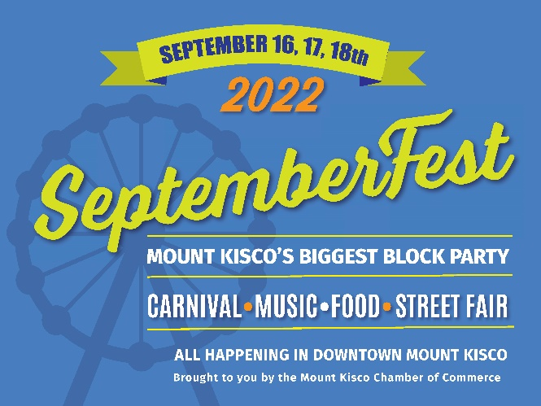
SeptemberFest is a supersized weekend of activities with
three action-packed days of activities designed to bring customers to you!

- Showcase your business, products and services at SeptemberFest’s Street Fair
- Meet and engage with new customers thru exclusive Festival Sponsorships
- Gain visibility and brand awareness thru participation opportunities
- Get creative and have fun with your team, family and community

General Schedule of SeptemberFest 2022

Friday, September 16, 2022
5pm-11pm - Family Fun Full-size Carnival w/rides & amusements
Eats & Ale Food Trucks and Beer Garden
Friday Night “Rock the Block” with Live Stage Entertainment

Saturday, September 17, 2022
11am-6pm - Street Fair with Vendor Opportunities
11am-11pm - Family Fun Full-size Carnival w/rides & amusements
Eats & Ale Food Trucks and Beer Garden
Saturday Night Fest Fun Party Night with Live Stage Entertainment

Sunday, September 18, 2022
12pm-4pm - Street Fair with Vendor Opportunities
12pm-8pm-Family Fun Full-size Carnival w/rides & amusements
Eats & Ale Food Trucks and Beer Garden (til 5pm)
Sunday Afternoon SeptemberFest Community Talent Showcase

Event Sponsorship & Street Fair Vendor Opportunities Available
Sign up now at: www. mtkiscochamber.com
or email for more information: mkccseptemberfest@gmail.com

Enjoy Exclusive Benefits of SeptemberFest Sponsorship
Brought to you by the Mount Kisco Chamber of Commerce
September 16, 17, 18, 2022

Premier SeptemberFest Sponsorships
- Top Premier sponsorship for SeptemberFest with custom event signage
- Acknowledgement as Premier SeptemberFest sponsor on pre-event and live social media and print advertising
- Facebook Live Interview with an Influencer on opening night
- VIP Tent access during SeptemberFest for your use to showcase your business and host guests
- One Street Fair Table in Promenade Area to promote your business
- Continuous public acknowledgments of your business in the Eats & Ale Area during festival dates
- Ten Unlimited Carnival Ride Day Passes
Premier SeptemberFest Entertainment Stage Star Sponsor $2000 (Exclusive)
- Your business name prominently displayed for all 3 days of the festival atop the Entertainment Stage
Premier SeptemberFest Eats & Ale Hospitality Tent Sponsor $2000 (Exclusive)
Your business name prominently displayed for all 3 days of the festival atop our entertainment stage in the food/beer garden area
- Your business name prominently displayed for all 3 days of the festival on the Fest’s Hospitality Tent
Premier SeptemberFest Mid-Midway Carnival Sponsor $2000 (Exclusive)
- Your business name prominently displayed for all 3 days of the festival on the Ticket Booths at entry with option for distribution of your business card or coupon offer to each ticket purchaser.
Festival Entertainment Sponsorships
- Presenting sponsor for Fest entertainment segment with custom signage at the event
- Acknowledgements in pre-event and live social media and print advertising
- VIP Tent access during your entertainment segment to showcase your business and host guests
- Multiple public acknowledgements during entertainment segment
- Five Unlimited Carnival Ride Day Passes
Friday Night “Rock the Block Party” w/Live Stage Entertainment Sponsorship $1500 (Exclusive)

Saturday Night “Fest Fun Party Nite” w/Live Stage Entertainment Sponsorship $1500 (Exclusive)
Sunday “SeptemberFest Community Talent Showcase” Sponsorship $1500 (Exclusive)
Carnival Fun Sponsorship
Midway Madness Sponsor (Rides, Games & Activities) $500 (Limited number available)

- Your name or logo displayed on signage at one designated Carnival Ride, Gaming Booth or Activity
- Listed as an event supporter in print advertisements: one pre-event and one post-event
- Social media post during SeptemberFest dedicated to your ride or game with your name
- Two Unlimited Carnival Ride Day Passes

